Let’s Walk Together! Walking School Bus Training Manual Resources
Contents
(1) Sample phone talking points to principal 2
(2) Sample informational handout to school staff 3
(3) Sample informational handout to parents 5
(4) Sample parent training flyer 6
(5) Sample committee meeting agenda 7
(6) Sample meeting sign-in sheet 8
(7) Sample phone tree 9
(8) Volunteer emergency contact information 10
(9) Sample map 11
(10) Sample launch flyer with bus route and bus schedule 12
(11) Sample student registration form 13
(12) Sample parent and student expectation registration forms 15
(13) Sample volunteer sign-up form 17
(14) Sample approved volunteer list 19
(15) Sample informational flyer to neighbors along bus routes 20
(16) Sample donation letter 21
(17) Sample photo release at event entrances 22
(18) Sample volunteer instruction card for day-of walking school bus 23
(19) Sample safety tips 24
(20) Principles behind child pedestrian injury for volunteer training 25
(21) Tips on training children about road safety for volunteer training 26
(22) Tips to safely cross roads 27
(23) Sample sensitive and personal information 27
(24) Example contingency plans for Walking School Bus 29

(1) Sample phone talking points to principal

- Hello [Mr./Ms. INSERT PRINCIPAL NAME]

- My name is [INSERT NAME] and I am interested in starting a Walking School Bus.

- Do you have a few minutes to talk with me about this program? Are you familiar with Walking School Buses? [IF NO, DESCRIBE]

- Walking School Buses are organized adult-supervised group walks to get children walking to school. Instead of being driven in a yellow school bus, children are dropped off at a designated meeting point. With adult Walking School Bus leaders, children walk together to school along the Walking School Bus route.

- I am very interested in this program because there are many community and health benefits.

- The program can:

- teach children how to walk to school safely
- help slow cars down around the school
- help reduce traffic congestion around the school to make morning pick-up and afternoon drop-off easier and smoother
- increase physical activity among students
- increase safety for children walking to school by walking in a group
- improve air quality around the school
- save time for parents
- help create more parent and community involvement in the school

- Your support is crucial to the success of this program. Would there be an opportunity to discuss how we can start this program? What date and time would be convenient for you?

- Thank you so much for your time.

(2) Sample informational handout to school staff

What is Safe Routes to School?
Safe Routes to School (SRTS) is a comprehensive approach to get more kids walking and bicycling to school safely and comfortably.
Why start a Safe Routes to School program?
The U.S. Department of Health and Human Services recommends that children engage in 60 minutes (1 hour) or more of physical activity each day, and that adults engage in 30 minutes of physical activity. Regular physical activity helps build and maintain healthy bones and muscles, reduces the risk of developing obesity and chronic diseases, reduces feelings of depression and anxiety, and promotes psychological well-being. Walking and bicycling to school each day is an easy way for children and adults to get the physical activity they need to lead healthier lives. Comprehensive Safe Routes to School programs can help address barriers to walking and bicycling.
What is a Walking School Bus?
The “Walking School Bus” is one of many possible Safe Routes to School education and encouragement programs. Students walk together to school as a group along a pre-determined route, chaperoned by several adult walk leaders. Parents can either drop their children off at the Walking School Bus “bus stop” or walk with their children.
The Walking School Bus is a fun and engaging way to get more students walking by walking together.
This program is especially successful when parents are interested in having their child walk to school, but are concerned about letting their child walk alone, unsupervised.
A Walking School Bus can occur annually, monthly, weekly or daily.
Benefits of a Walking School Bus
The program can:
- teach children how to walk to school safely
- help reduce traffic congestion around the school, as more children choose to walk
- increase physical activity among students
- increase safety for children walking to school by walking in a group
- improve air quality around the school
- save time for parents
- help create more parent and community involvement in the school
Steps to Walking School Bus Success
A successful Walking School Bus program depends on an organized, dedicated committee. The committee can be made up of volunteer parents, school staff, and interested community members, donating their time and energies to launch the program. If you are interested in learning more or being a part of the committee, please contact us!
Contact Information
[INSERT CONTACT]

(3) Sample informational handout to parents

[SCHOOL]
“Walking School Bus” Information Handout
What is a Walking School Bus?
A Walking School Bus is a fun way to get to school as a group! Children walk under adult supervision along a recommended route to school.
Why should I join?
A Walking School Bus is an opportunity for children to learn important pedestrian safety skills. Walking School Buses can help reduce the number of parents dropping off children to school, which means reducing traffic congestion and improving air quality around the school. In addition, if your child participates, they will get more physical activity, which will help keep them healthy and prepare them to learn for the day. Finally, it will save you time. Imagine volunteering for the Walking School Bus just once a week, and having four free days where you don’t have to worry about getting your child to school!
What does it cost?
The program is free! It relies on adult volunteers, and the more volunteers, the more days a walking school bus can run.
How do I sign up my child?
It’s easy! Just fill out the attached Walking School Bus Consent Form and return it to your school.
Who can be a volunteer with the Walking School Bus?
All parents, family members, and school staff who have been cleared by [SCHOOL/ SCHOOL DISTRICT] volunteer screening process. [TAILOR FOR YOUR SITUATION]
We hope that you will join and help volunteer with the Walking School Bus! It’s a great way to spend time with your child before school.
If you are interested in volunteering, please complete the attached Walking School Bus Volunteer Form.
TO LEARN MORE, PLEASE CONTACT: [INSERT WEBSITE OR CONTACT INFO]

(4) Sample parent training flyer

Parent Training
Be part of the Walking School Bus!
Helping kids arrive to school alert and ready to learn

Increasing student safety by reducing traffic around campus

Teaching valuable lessons about pedestrian safety

Reducing financial and time constraints for parents

Learn everything you need to know to volunteer for this great program!
When: [DATE]
Time: [TIME]
Where: [LOCATION]

(5) Sample committee meeting agenda

[SCHOOL]
[TIME]
Walking School Bus Program Agenda
- Introduction
- Purpose – International Walk to School Day
- International Walk to School Day planning steps
  - Decide on meeting location and route
  - Who will be walk leaders?
  - Decide on start time
  - How can we make it exciting?
  - How do we advertise?
  - How do we recruit other volunteers?
- Schedule Future Meetings
  - Who will lead the meeting?
- Communication Tree
- Next Steps

(6) Sample meeting sign-in sheet

[NAME OF SCHOOL]

[NAME] | [PHONE] | [EMAIL] | [SCHOOL] | Signature: I give my consent to be photographed at this meeting by [SCHOOL/STAFF]

(7) Sample phone tree

PURPOSE
- The primary purpose of a phone tree is to quickly spread brief messages to a large number of people
- Phone trees are only effective when the messages are shared clearly and accurately
- Messages must be delivered in a timely manner

INSTRUCTIONS
- The process is initiated when the primary contact on the list (top box) calls the secondary contacts
- The secondary contact then calls the persons who are next on the list
- Call all persons on the tree until you have delivered the message. If they do not answer, leave a message

(8) Volunteer emergency contact information

Volunteer Information
Name
Address
City & Zip Code
Cell Phone Number
Home Phone Number
Email Address
Primary Contact
Name
Relationship
Cell Phone Number
Home Phone Number
Work Phone Number
Secondary Contact
Name
Relationship
Cell Phone Number
Home Phone Number
Work Phone Number
Additional Medical Information?

Signature ____________________________Date __________________
To be kept on file by the Walking School Bus Coordinator.

(9) Sample map

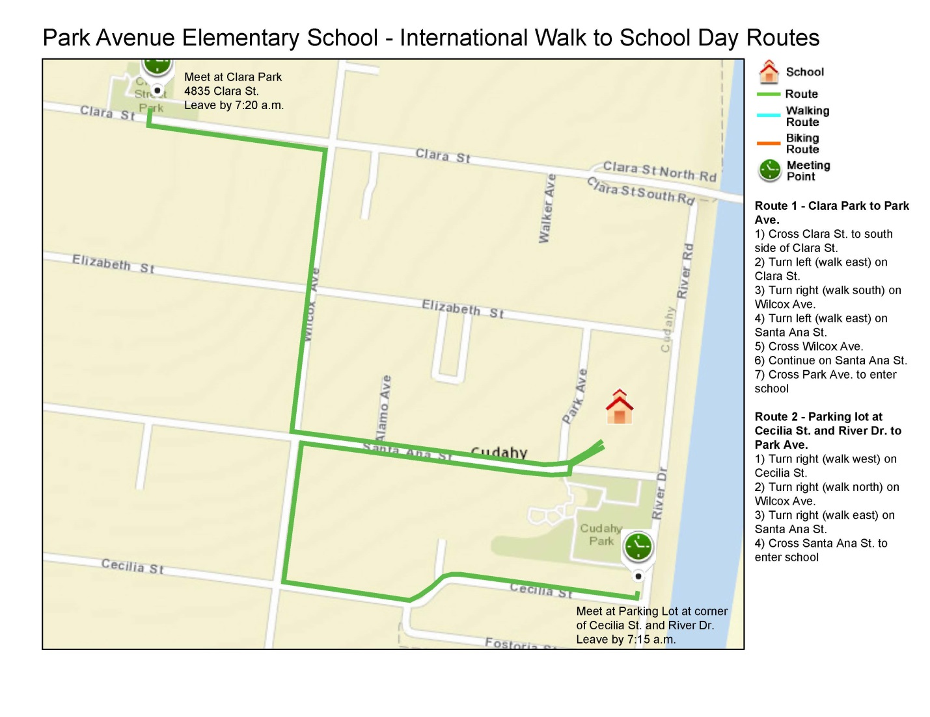

(10) Sample launch flyer with bus route and bus schedule

LET’S GET WALKING!
The Walking School Bus is a fun, safe, and active way for children to get to school!
We now have a Walking School Bus route from [INSERT LOCATION], walking to school every [INSERT DAYS OF WEEK AND TIME]. Please arrive a few minutes early at your bus stop and help us get to school on time!
Bus Schedule [INCLUDE MAP IF AVAILABLE]
Bus Stop | Bus Leaves
[INTERSECTION] | [INSERT TIME]
[INTERSECTION] | [INSERT TIME]
[INTERSECTION] | [INSERT TIME]
[SCHOOL NAME] | [INSERT TIME]

By participating in the Walking School Bus, you are eligible for fun, free prizes!

Remember to register before participating. You can find registration forms at [INSERT LOCATION].

- Are you interested in helping your Walking School Bus and gaining the benefit of a morning walk?
- Are you interested in walking from another area?
- Would you like any other information?

Please contact [INSERT] for more information

(11) Sample student registration form

Walking School Bus Consent Form for [YEAR] School Year
If you would like your child to join a Walking School Bus, please complete and return the completed form to the front office by [INSERT DATE].
If you have any questions, please contact [INSERT NAME AND CONTACT INFORMATION].
PARTICIPANT DETAILS
Please provide details for your child(ren) who would like to use the walking school bus.
First Name | Surname | Age

HOME ADDRESS
___________________________________________________________
___________________________________________________________
___________________________________________________________

2. Potential Risks
The Walking School Bus is intended to reduce the risk of injury to children as they travel to and from school through the use of adult supervision. However, there are risks associated with child pedestrians. These specific risks include injury as a result of motor vehicle crashes, a fall, overexertion, or carelessness. [SCHOOL] does not assume responsibility for the safety of walking or bicycling routes and encourages families to decide whether the recommended Walking School Bus route is suitable for their children.
3. Voluntary Consent
I certify that I have read this consent form or it has been read to me and that I understand the program and its risks. A copy of this consent form will be given to me. By signing this consent form, I agree to allow my child to participate in this program.
4. Photo Release (Potential risk- Please check with school)
I authorize the [INSERT SCHOOL] and its affiliates to photograph, film, audiotape, or otherwise record and/or interview (collectively, “Materials”) myself and my child(ren). Further, I agree that such Materials may be used, with or without my name, in any publications, presentations, websites or other media form, whether nor or hereafter known, for any purpose that, in the view of [INSERT SCHOOL], in its sole discretion. I further understand and agree that I have no rights in the Materials, and that these Materials may be edited, used, published, distributed, and/or licensed by [INSERT SCHOOL] now or at any time in the future, for the purposes set forth above. I waive all right to inspect or approve the use of the Materials, now or in the future.
Minor’s Full Name (Print): _______________________________________________________
Relationship to person completing this form: ________________________________________
Parent/Guardian Name: _________________________________________________________
Address:______________________________________________________________________
City: __________________________ State: ______ Zip Code: __________________________
Phone Number: __________________________ Email Address: __________________________
Parent or Guardian Signature: __________________________________ Date: ______________

(12) Sample parent and student expectation registration forms

Parent Expectations

- Parents are expected to complete all paperwork required by the Walking School Bus program to enroll your child(ren) in the program (e.g., permission slip, child and parent expectation sheets, emergency contact information).
- Parents are welcome to walk along with the Walking School Bus until you feel comfortable with the volunteers and children on the route. However, if you wish to walk every day, you must complete the volunteer process.
- It is the responsibility of the parent to determine the way they wish to deliver the child(ren) to the Walking School Bus leader (a.k.a. walkleader) (e.g., walk them to the bus stop, allow them to walk on their own).
- Children must arrive on time at the pre-determined “bus stop” drop off locations. The school bus will leave bus stops on time and cannot wait for children who are late. If a child misses the bus, the parent is responsible for getting him or her to school.
- If a walk needs to be cancelled for an exceptional circumstance, the Walking School Bus Coordinator will contact the parents on the route.
- Parents are expected to be aware of safety procedures, incident reporting, and appropriate responses to student conduct. These safety procedures are all in place for the safety of the children and volunteers.
- Safety for all parties involved is of utmost importance in our program. Parents should provide emergency contact information, and any other relevant information to appropriate school staff and the Walking School Bus Coordinator.
- Parents who have a child with special needs or requests should contact their school’s Walking School Bus Coordinator.
- The Walking School Bus Coordinator reserves the right to ask parents or students who fail to follow the rules to cease participation in the program.
- In order to provide the best volunteer experience possible, [Insert] School District/School reserves the right to amend or update this policy as needed.
- Most importantly, the purpose of the Walking School Bus is an educational, physical activity, and community building program. Support it, participate in it, and have fun with it!

I understand and agree to the roles, responsibilities, and liabilities of a parent with a child in the Walking School Bus program as defined under the [INSERT NAME] school district’s policies and procedures.

_____________________________________________ _________________
Signature of Parent/Guardian Date

_____________________________________________ _________________
Print Name School

Student Expectations

Prior to your family’s participation in the Walking School Bus program, please review the following rules and expectations together. This is a crucial step to make this a fun and safe experience for your family!

Safety Rules
- There will be one Walking School Bus leader walking in front of the children and one behind.
- When getting ready to cross a street, children are to stop and wait for instructions before crossing.
- Children should follow directions and “look left, look right” when crossing the street.
- No running is permitted at any time.
- Children should stay within the crosswalk when crossing the street.
- Volunteers will remind children to be aware of traffic at driveways, intersections, and other thoroughfares.
- Participants will be respectful of all other students, the walk leaders, the neighborhood, and neighbors.
- Children will not use electronic devices during the walk.
- Volunteers will give a verbal warning if these rules are not followed, and if the behavior persists, the volunteer will alert the school.

I have read and understand the role and responsibilities of a Walking School Bus Participant with my parent(s)/guardian(s) and agree to follow these rules. Most of all, I agree to have fun!

__________________________________________________ ___________________
Student Signature Date

__________________________________________________ ___________________
Print Student’s Name School

__________________________________________________
Print Parent’s Name

(13) Sample volunteer sign-up form

Walking School Bus Volunteer Form
Are you a family member or guardian of a [SCHOOL] student and willing to volunteer with the [SCHOOL] Walking School Bus? If yes, please complete the questions below and return it to [NAME AND LOCATION]. Thank you!
1. Please provide the name/s of the volunteer/s and their contact details
 | Volunteer 1 | Volunteer 2
Name
Phone
Email

2. Please pick which [DAY]/s the volunteers would be able to escort a Walking School Bus
 | Volunteer 1 |  |  |  | Volunteer 2
 | 1st [DAY] | 2nd [DAY] | 3rd [DAY] | 4th [DAY] | 1st [DAY] | 2nd [DAY] | 3rd [DAY] | 4th [DAY]
Mornings [or Afternoon] from [TIME]
Please list any [DAY] dates you can NOT volunteer

3. If you’re unable to commit to one regular walking [DAY] a month throughout the school year, but are interested in a specific date please indicate which [DAY] throughout the school year you can commit to volunteering
 | Please list the actual dates from [TIME FRAME]
Volunteer 1 | [DAY]:
Volunteer 2 | [DAY]:

4. Please check this box if you would like to be a back-up volunteer but are unable to commit to any [DAY] at this point.
5. Volunteer Commitment
I agree to be a volunteer Walking School Bus leader along the recommended route to school. If I should be unable to make any commitments, I agree to contact [NAME] at least 2 school days beforehand or will arrange for a substitute volunteer from the approved list. I agree to follow the safety rules of the Walking School Bus program during my role as a volunteer.
Print Name: ________________________________
Signature: _____________________________
Date: ________________________

(14) Sample approved volunteer list

Name | Phone | Email | Emergency Contact | Volunteer Role | Scheduled Shift | Can  Cover

(15) Sample informational flyer to neighbors along bus routes

Dear Neighbor,
[INSERT SCHOOL] has started a Walking School Bus program as part of the nationally recognized Safe Routes to School program. We would like to invite you to participate!
What is a Walking School Bus?
- Students walk together to school as a group along a pre-determined route, chaperoned by several adult walk leaders. The Walking School Bus is a fun and engaging way to get more students walking by walking together.
- A Walking School Bus can occur annually, monthly, weekly or daily.
- The program is free. It relies on volunteers; the more volunteers, the more days a Walking School Bus can run, and more children can participate.
What are the benefits of a Walking School Bus?
- Helps slow cars down around schools and its neighborhood, making it safer for people walking, bicycling, and driving;
- Helps reduce traffic congestion around schools and the neighborhood as more children choose to walk;
- Increases physical activity and safety for parents and students;
- Improves air quality around schools and its neighborhood by reducing traffic congestion and greenhouse gas emissions; and
- Increases community involvement and strengthens community relationships.
We now have a Walking School Bus route from [INSERT LOCATION] walking to school every [INSERT DAY and TIME].
We invite you to come out to your front door and greet the children walking to school through the neighborhood. They would love the encouragement!
- Are you interested in helping the Walking School Bus and gaining the benefit of a morning walk?
- Are you interested in walking from another area?
- Would you like any other information?

Please contact [CONTACT] for more information

(16) Sample donation letter
[DATE]
[ADDRESS]
To Whom It May Concern:
[SCHOOL] is working to develop a Safe Routes to School Walking School Bus program. Safe Routes to School is a nationally recognized program designed to make walking and biking to school easier and safer for children. This program has benefits such as:
- teaching children how to walk to school safely
- helping slow cars down around the school
- helping reduce traffic congestion in the neighborhood and around the school
- increasing safety for children walking to school by walking in a group
- improving air quality around the school

The “Walking School Bus” is an adult-supervised group walk to and/or from school. The Walking School Bus is a fun and engaging way to get more students walking, by walking together.
We are asking for your support by donating items to increase participation and engagement of children, parents, and the community. Specifically, we are looking for:
- Healthy food items
- Incentive items for children such as: stickers, reusable water bottles, t-shirts, pencils
- Incentive items for parents and community members such as: re-useable bags, gift cards
- Program equipment such as: safety cones, safety vests, storage bins, banners
The Walking School Bus program will benefit greatly from your involvement and donation. We would be pleased if you would examine your inventory and consider donating. If you have any further questions or are interested in donating, please feel free to contact [INSERT CONTACT].
Thank you for your support, and continued work to make our community a great place!
Sincerely,
[INSERT NAME]

(17) Sample photo release at event entrances

[REVIEW FORM WITH YOUR SCHOOL FOR USE AND LANGUAGE]

Photo Release
By participating in [EVENT], you and your child(ren) consent to their voice and likeness being videotaped and/or photographed and used without compensation for exploitation on television and in any and all media now known or hereafter devised, and you release [SCHOOL OR SPONSORING ORGANIZATION] from any liability on account of such usage.

(18) Sample volunteer instruction card for day-of walking school bus

Instructions for Adult Walking School Bus Leaders

Thank you so much for leading the Walking School Bus! To ensure a smooth morning, please keep the following in mind.

- Wear safety vests.
- Collect registration forms or confirm participating students on registration checklist.
- If 3 volunteers are available, assign one bus leader to be the intersection chaperone. Designate one bus leader to stay in front of walking school bus, and rear chaperone.
  - Before crossing intersections, lead bus leader waits for intersection bus leader and majority of children to minimize crossings and disrupting traffic.
- Rotate students to hold the banner (if you have one).
- Reiterate rules to children:
  - Never pass the lead chaperone.
  - Stay on sidewalk.
  - Do not walk on neighbor’s lawns.
  - Do not run.
  - If you have a bike or scooter, walk it.

(19) Sample safety tips

[To be read to students prior to starting the walk]
Safety Tips

- Listen to your Walk Leaders
- Stay in-between Walk Leaders
- Stay on sidewalk
- Walk, do not run
- Have fun!

(20) Principles behind child pedestrian injury for volunteer training

1. | Young children are less likely to take notice of objects that are not directly in front of them. | - Unless they deliberately turn their heads, they may not notice vehicles on the left or right.  - Looking behind is essential behavior when at intersections.  - It is essential that children practice the look behind-right-left-right road safety strategy and understand the reason for the sequence for most road crossings.
2. | Children have difficulty judging the speed of approaching traffic. | - Children may wait for a slow car but cross in front of a fast one.  - This behavior is related to the size and sound of a vehicle.  - Small vehicles are perceived as being far away and large vehicles are thought to be closer.
3. | Young children often have difficulty judging the direction from which sound is coming. | - Children may expect traffic to come from a different direction.
4. | Because children are small, they often cannot see over parked vehicles or roadside shrubs. | - This also means that motorists cannot see them.
5. | Children have a short attention span and attend to those sights and sounds that interest them. | - This inconsistency of behavior is also influenced by interaction with others.
6. | Children behave spontaneously, based on impulse. | - Children can be unpredictable.  - Their high activity level and developing coordination increases this problem. The result is that if moving quickly, they may not be able to stop quickly in an emergency.

(21) Tips on training children about road safety for volunteer training

An important role of volunteers is educating children on road safety. Some examples include:
- Scanning the road environment. This means children should be reminded to physically turn the head from side to side to compensate for their reduced peripheral vision.
- To cross or not to cross a road. This helps children to understand the decision making process. This may include counting the time vehicles take to travel from sighting to crossover point and comparing this to the time taken to cross the road with time to spare.
- Hearing a traffic sound, children should begin scanning until they have identified the source and whether the vehicle could be a threat to their safety.
- If they do not have a clear view of the road in all directions, then drivers probably cannot see them until too close to stop a collision.
- Approach pathway ends and road boundaries with caution and STOP, LOOK (behind- left-right-left), LISTEN and THINK.
- Improve children’s concentration by asking questions that cause the child to focus on a given potential or actual hazard.
- Being aware of the influence that children have on each other’s behaviors.

(22) Tips to safely cross roads

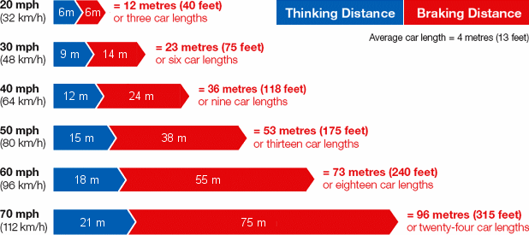
It is going to take you at least 15 seconds (and very likely longer) to get every child across a street.
Safety Strategies
- Gather the group at least 1 yard back from the curb before crossing.
- Estimate the crossing time (depending on the number and age of children—remember that running is not allowed).
- Estimate the ‘no-go’ point (a point 20 seconds away in each direction)
- Cross the busy roads with small numbers of children (up to 6) but allow a minimum of 15 seconds for the same circumstances above.
- Cross ONLY when a fresh walk signal has illuminated, if applicable.

Crossing Roads
- Do not allow children onto a road because a driver has stopped mid-block and waved them across.
- Holding them well back from the curb reduces the risk that this will happen.
- Do not commit groups of more than 10 to cross-traffic road crossings.
- Do not assume motorists will stop.
- Do not attempt to stop traffic in order to cross a road.
- Communicate clearly before moving onto roads.
- Keep the sub-group together and maintain verbal contact.
- Regroup away from the crossover point so others can clear the road.

(23) Sample sensitive and personal information

Sick Children: It is the parent’s responsibility to determine if their child can go to school. If a child joins the Walking School Bus and they are ill, call the school to seek additional guidance.
Sensitive and Personal Information: Volunteers are expected to hold sensitive and personal information in confidence. Gossiping or sharing it with other parents is unprofessional and unacceptable. The exception is to inform the principal immediately of sexual, physical, financial, or other types of abuse. While in this role, you are not a mandated reporter; however, informing the principal is very important that he/she may take appropriate action.
Child abuse may look like this:
- Physically injured by other than accidental means, subjected to willful cruelty or unjustifiable punishment.
- Neglect by a parent or caretaker who fails to provide adequate food, clothing, shelter, medical care, or supervision.
- Emotional Abuse—Attacking the emotional well-being and stability of the individual
- Physical Abuse—Harming the physical well-being of an individual
- Neglect—Harming an individual by abandoning, ignoring, or rejecting basic needs
- Sexual Abuse—Harming an individual through inappropriate sexual contact, lewd behavior, or exploitation
- Ethical Abuse—Harming an individual by convincing him/her to commit an act that is against his/her physical, moral, or ethical interest

(24) Example contingency plans for Walking School Bus

Unexpected things can occur during a walk.
Here are some examples:
- A child joins in the Walking School Bus without a parent consent record on file.
Action: The child is asked if he/she intends to be a regular participant on the bus. If so, issue a consent form, enter the child on the Incident Report and assume responsibility for the child for that day.
If the child intends to ‘drop in’ occasionally, he/she requires a signed permission note from the parent and must hand this to the Volunteer Coordinator on those days.
- A volunteer is unable to meet his or her scheduled commitment.
Action: The volunteer organizes a replacement and advises the Walking School Bus Volunteer Coordinator. Or, the volunteer will contact the Volunteer Coordinator who will ask a stand-by volunteer to attend.
- A child or volunteer is unable to complete the trip because of sickness or an injury not considered serious enough to require an ambulance.
Action: Contact the Walking School Bus Volunteer Coordinator and school’s office for assistance.

