
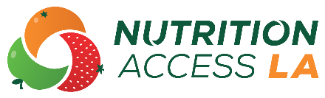
SCHOOL MEALS FACT SHEET
YOUR LOGO HERE
Many schools provide students with access to meals through the National School Lunch Program and the School Breakfast Program. All students can participate in these school meal programs. Some students are eligible to receive meals for free or at a reduced-price based on their family’s income. The meals include a variety of fruits, vegetables, whole-grains, meats or meat alternatives, and milk. School Meals offer students nutrients they need to grow and learn.
How can I apply for free or reduced-price school meals?
Any student at a participating school can buy breakfast and/or lunch. Some students may qualify for free or reduced-price meals. Schools send school meal applications home at the beginning of the school year. You may ask for an application any time during the school year. Applications are reviewed by the school or district to determine if students qualify for free or reduced-price meals based on their household income.
If your household receives CalFresh benefits, all children who attend school automatically qualify for free school meals. Contact your school to ask if you need to complete an application and to learn more about the school meals program.
What other information should I know?
Some schools may offer both the School Breakfast Program and National School Lunch Program, while some schools may offer one meal program. Contact your school for more information.
 | Note for the 2021-2022 School Year  Many districts are offering free meals for all students during the 2021-2022 school year. Districts can do this because the United States Department of Agriculture (USDA), which oversees the program at the national level, has allowed for certain changes during the COVID-19 pandemic.

Visit the California Department of Education website at cde.ca.gov for questions and more information about school meals.

