
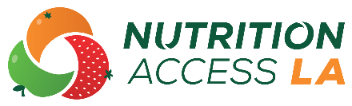
HOME-DELIVERED MEALS PROGRAM FACT SHEET
YOUR LOGO HERE
The Home-Delivered Meals Program is a healthy meal delivery program for older adults who are homebound. Older adults can have meals delivered to their home by volunteers if they cannot plan, shop, or prepare meals for themselves due to illness, disability, or advanced age. The program also provides an opportunity for safety checks and short visits by volunteers, which can help reduce feelings of loneliness.
Who is eligible for the Home-Delivered Meals Program?
You must meet ONE of the following requirements to be eligible for the Home-Delivered Meals Program:
- Age 60 years or older who is homebound due to illness, disability, or isolation
- Person under 60 years old with a disability living with someone who is age 60 years or older who is homebound
- Spouse or partner of a homebound older adult
How do I apply for the Home-Delivered Meals Program?
 | Call the County of Los Angeles Information and Assistance Line at  1-800-510-2020. |  |  | You will be directed to a Home-Delivered Meals Program service provider in your area.

What other information should I know?
Meals arrive either hot or frozen, depending on participants’ preference and ability to reheat meals. The program is free but asks participants to donate between $1.75 and $3.00 per meal if possible.
Visit the Area Agency on Aging website at
wdacs.lacounty.gov/services/older-dependent-adult-services for questions and more information about the Home-Delivered Meals Program.

