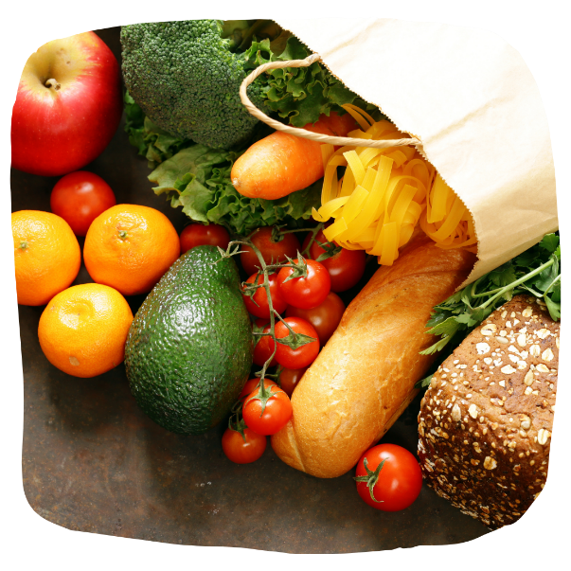
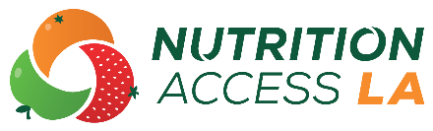
CALFRESH FACT SHEET
YOUR LOGO HERE
CalFresh Food, formerly known as food stamps, is a program that can help you buy healthy food and manage your food budget. CalFresh Food benefits are giving through an electronic benefit transfer (EBT) card, which works like a debit card. Most grocery stores, corner stores, and farmers’ markets accept EBT. The amount of CalFresh Food benefits you receive depends on your income, expenses, and household size.
Who is eligible for CalFresh?
You must meet the following requirements to be eligible for CalFresh:
- U.S. citizens, legal residents, and some qualified immigrants
- Individuals or households with low or no income who meet other eligibility requirements
- Non-citizens can apply for other household members who are citizens or legal residents, such as children
How do I apply for CalFresh?
 | Phone: Call the Customer Service Center (CSC) at 1-866-613-3777 and select “Apply to CalFresh” option.
 | Online: Apply online at www.dpss.lacounty.gov or GetCalFresh.org.
 | Mail: Call the CSC at 1-866-613-3777 and ask for a CalFresh application to be mailed to you. Once you have filled out your application, mail it to your local Department of Public Social Services (DPSS) office.

What other information should I know?
It can take up to 30 days to process your CalFresh application. In emergencies, a household may receive benefits within three (3) days from the date of their application. Call 1-866-613-3777 to learn more about this service. If you are a Supplemental Security Income/State Supplementary Payment (SSI/SSP) recipient and applying to CalFresh, make sure to report all your medical expenses to maximize your benefits. Medical expenses include medications, health and medical supplies, home health services, insurance co-payments, and others.
Visit the Department of Social Services website at dpss.lacounty.gov for questions and more information about CalFresh.

