APPENDIX C: MCC REGISTRATION SCREENING TOOL

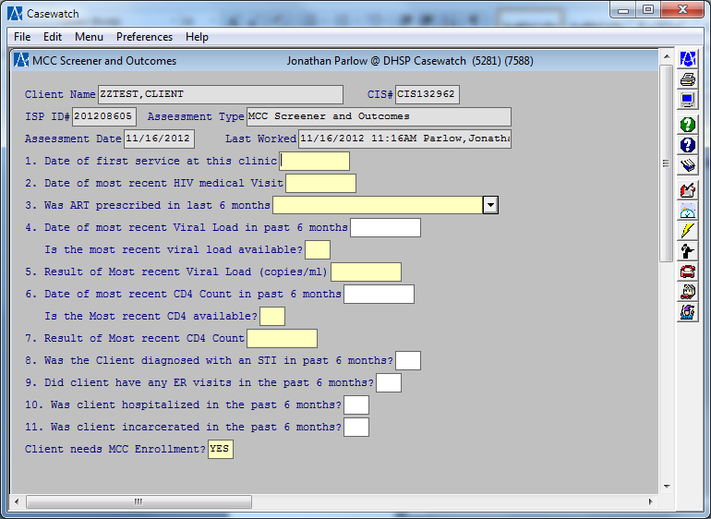
- Data will be pulled over where applicable (#1-2, 4-7)
- “Client needs MCC Enrollment” field calculated based on answers and will indicate whether client in need of active MCC or not.
- If client is in need of active MCC, “Tracking for Active MCC Clients” will be required within 30 days of the MCC Screener and Outcomes.

